**Digital Campaign Performance Study**

**Overview**

The Digital Campaign Performance Study report provides the client with campaign results (CTR, VCR, total number of impressions, delivery progress) and compares them to standard benchmark values. It breaks down performance by creatives, line items, platforms and device types to allow further understanding.

The template of the report can be found here.

**What you will need**

To create a Digital Campaign Performance Study, you may need:

* Your campaign ID and campaign name
* The campaign flight dates
* The number of impressions Alphonso initially committed to (from deal sheet)
* The brand logo
* Screenshots of the advertisement

**Digital Campaign Performance Study Report Summary**

$vcr=\frac{video completes}{impressions}×100$ $ctr=\frac{clicks}{impressions}×100$

* vtr benchmark for mobile/tablet/CTV: 85%
* vtr benchmark for desktop: 75%
* ctr benchmark: 1%

Beeswax Query Tool is [here](https://alphonso.beeswax.com/login?u=%2Fadvertisers), in Reporting > Query Tool

|  |  |  |  |  |  |
| --- | --- | --- | --- | --- | --- |
| **Slide** | **Type of Report** | **Fields** | **Metrics** | **Filter** | **Observation** |
| Summary | Performance | CID  (or name) | CTR  Impressions  Video Completes | Filter on your campaign | Need to calculate vcr |
| Timeline | Performance | Day or month | Impressions | Filter on your campaign | Day/month depending on length of campaign. |
| By targeting tactic | Performance | LID (or name) | Impressions  Clicks  Video Completes | Filter on your campaign | Associate each line item to a targeting tactic. Then sum and calculate vcr and ctr |
| By creative | Performance | Creative name (or ID) | Impressions  CTR  Video Completes | Filter on your campaign | Need to calculate vcr |
| By hour of day | Performance | Hour | Impressions | Filter on your campaign | Copy paste the columns you obtain (Hour/Impressions) in this file to obtain the data. |
| By |  |  |  |  |  |

**Detailed Breakdown of the slides**

**Title Slide and Preface Slide**





*Change the picture, the dates, the names and the flight dates*

**Campaign Summary Slide**



*Change the 3 campaign metrics, add pictures in the tablet, modify the summary sentences to highlight what the goals of the campaign were (conquest, conquer, target)*

How to generate the number of impressions, the CTR, the VCR?

Log into Beeswax (<https://alphonso.beeswax.com/login?u=%2Fadvertisers>)

Go to Reporting > Query Tool

Fill in the following fields

* Report type: Performance Report
* Date: none, or your campaign flight dates
* Fields: campaign ID or campaign name
* Metrics: CTR, Video Completes, Impressions

*Note that Beeswax has a Video Completion Rate metric, but this metric corresponds to Video Completes/Video Plays, when the metric Alphonso uses is Video Complete/Impressions. This is why the VCR will be calculated by hand without relying on Beeswax VCR metric.*

* Select the campaigns you need in Campaign ID or Campaign Name
* Choose your format (xls or csv) and give the report a name

Run the report, download it and open it

Your ctr is included in the column “ctr” (it is a percentage)

*Note that Alphonso internal benchmark for ctr is 1%, external is 0.56%*

The video completion rate is calculated as $vcr=\frac{video completes}{impressions}×100$

*Note that Alphonso benchmarks for vcr are 65% for Desktop and 75% for mobile/tablet*

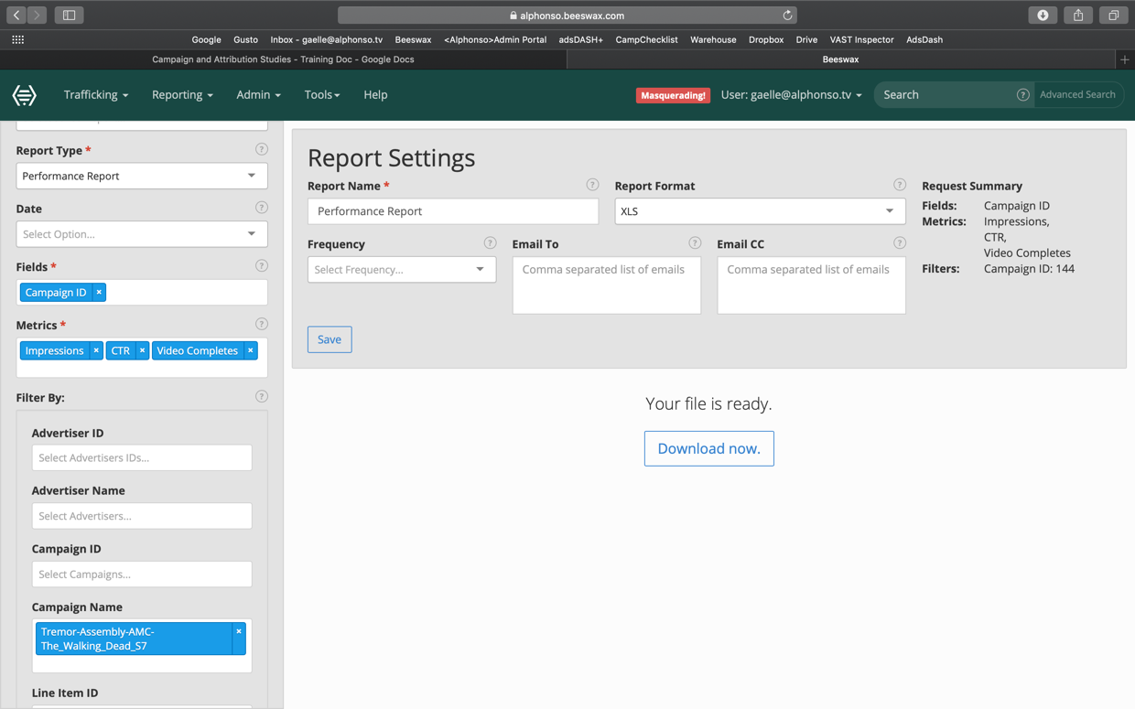

Figure 1 – The Beeswax Query Tool

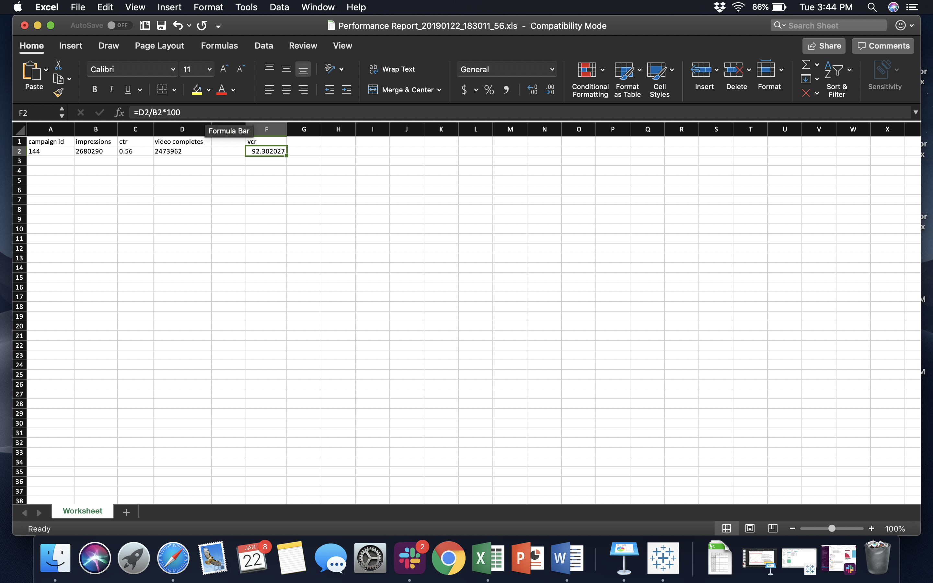

Figure 2 – The report generated on Excel and vcr calculation

🡪 Those campaign numbers are also available on the Adsdash+ portal

**Campaign Delivery Progress and Summary Slide**



To generate the graph, use Beeswax to generate a report similar to the one in the previous slide:

* Report type: Performance Report
* Date: none, or your campaign flight dates
* Fields: Day or Month (or Hour for a short campaign), depending on how long the campaign was
* Metrics: Impressions

Once you have the data, create a new column containing the cumulative sum of impressions as a percentage of the committed budget (in impressions). To do this on excel you can for example use the formula =SUM($B$2:B2)/Budget)*100 and drag it down (where B is the column containing impressions)

$$Impressions \left(\%\right)=\frac{CumSum(impressions)}{Committed Budget}×100$$

For CPVC campaigns, remember that the budget (in impressions) is the budget specified in the Deal Sheet (in video completes) divided by 0.8. So $$Impressions \left(\%\right)=\frac{CumSum(impressions)}{Committed Budget}×0.8 ×100$$

Then generate the graph:

* copying the columns Day/Month/Hour and impressions (%)
* in the Keynote presentation, click edit data
* paste the data

The delivered% of committed impressions will be the number you reach on the last day of the campaign. Note that you can also plot the number of impressions each day to identify any particular events that occurred during the campaign (peak day, pause)

The CTR and VCR are to be compared to the benchmark CTRs and VCRs.

* Benchmark CTR is 1%, so the campaign’s CTR is $Campaign CTR×100\%$ of benchmark CTR
* Benchmark VCR is 75%, so the campaign’s VCR is $\frac{Campaign CTR}{75}×100\%$ of benchmark VCR

**Performance Study by Targeting Tactic Slide**



For this slide you need to associate with each line item one of the following targeting tactics:

* Conquer: target the viewers of a competitor’s ad
* Complement: target the viewers of your own ad
* Content: target the viewers of a particular TV content

In order to obtain the numbers for the various targeting tactics, generate a report by Line Item in the following way:

* Report type: Performance Report
* Date: none, or your campaign flight dates
* Fields: Line Item name or Line Item ID
* Metrics: Impressions, Clicks, Video Completes

Then sum all of the lines corresponding to the line items for each strategy and compute the corresponding number of impressions, ctr and vcr.

**Performance Study by Platform and Device Type**



In order to obtain the numbers for this slide, generate a Platform report in the following way:

* Report type: Platform Report
* Date: none, or your campaign flight dates
* Fields: Platform OS
* Metrics: Impressions, ctr, Video Completes

For the device type, change the field to Device Type and rerun the report.

As before, the video completion rate is computed as $vcr=\frac{video completes}{impressions}×100$

**Performance Study by Creative**



In order to obtain the numbers for this slide, generate the following performance report:

* Report type: Performance Report
* Date: none, or your campaign flight dates
* Fields: Creative Name
* Metrics: Impressions, ctr, Video Completes

As before, the video completion rate is computed as $vcr=\frac{video completes}{impressions}×100$

You may also want to look at the length of the creatives to see if the length has an impact on the vcr.

**Performance Study by Applications**



In order to obtain the numbers for this slide, generate the following Mobile App report:

* Report type: Mobile App Report
* Date: none, or your campaign flight dates
* Fields: App Bundle
* Metrics: Impressions, CTR, Video Completes

As before, the video completion rate is computed as $vcr=\frac{video completes}{impressions}×100$

Once you have obtained the report, use excel to sort the apps by descending order of impressions, and copy the top 15 apps to the Keynote presentation along with their completion rate.

**Digital Campaign Delivery by Day Part Slide**



In order to obtain the numbers for this slide, generate the following App Bundle report:

* Report type: Performance Report
* Date: none, or your campaign flight dates
* Fields:Hour
* Metrics: Impressions

You then need to match each date to an hour, and each hour to a day part.